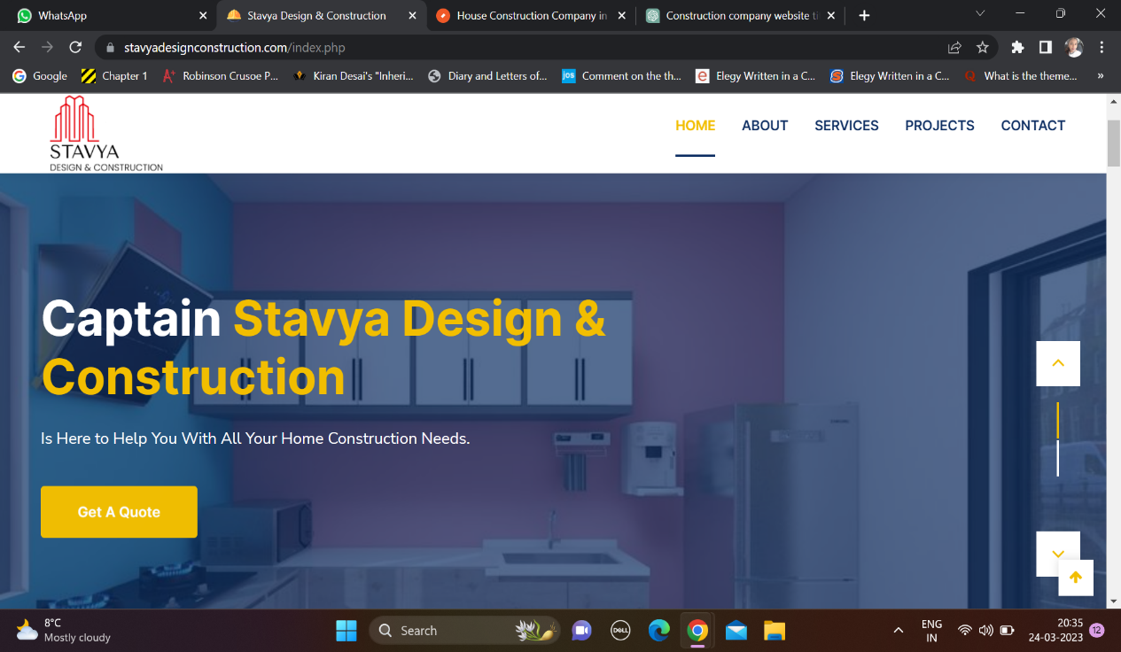

Current – Is here to Help you with all your Home Construction needs.

Suggestion - From design to delivery, we are with you every step of the way.

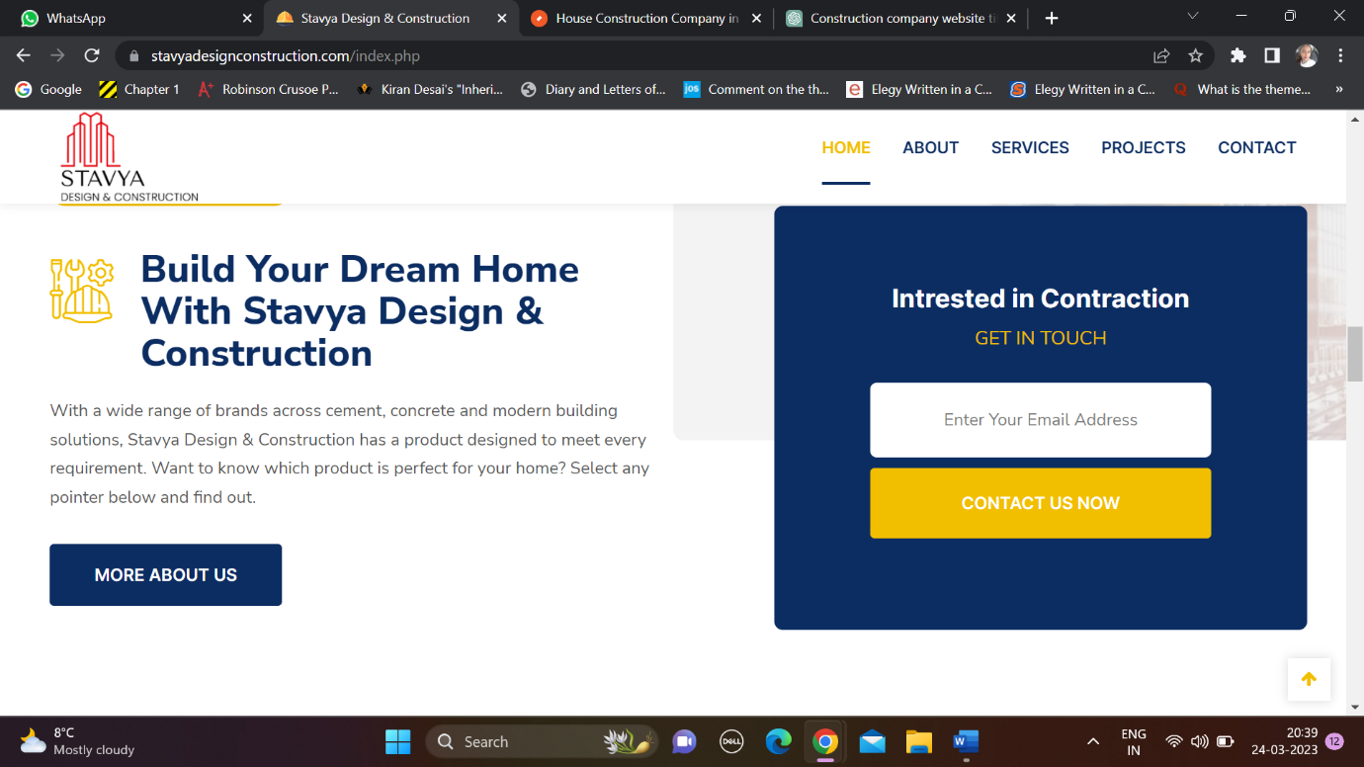

Current - With a wide range of brands across cement, concrete and modern building solutions, Stavya Design & Construction has a product designed to meet every requirement. Want to know which product is perfect for your home? Select any pointer below and find out

Suggested - Welcome to our construction company, where we pride ourselves on delivering exceptional results and providing top-quality services to our clients. With years of experience in the industry, we have built a reputation for excellence in construction, renovation, and remodelling. Our team of skilled professionals is committed to bringing your vision to life, working closely with you to understand your needs and exceed your expectations. From small home renovations to large commercial projects, we have the expertise and resources to take on any job with precision and attention to detail. Let us help you turn your dream project into a reality.



Suggested - At our construction company, we are proud to be a leading provider of high-quality construction, renovation, and remodelling services. With a team of experienced professionals and a commitment to excellence, we have completed over 2854 projects, ranging from small residential renovations to large commercial buildings. Our portfolio showcases our expertise in a wide range of construction projects, including custom homes, office buildings, retail spaces, and more.

We are dedicated to building lasting relationships with our clients, and our 3 million company followers are a testament to our commitment to exceptional customer service. We believe in providing personalized attention to each project, ensuring that every detail is carefully considered and executed with precision.

Our success is driven by our passion for excellence and our commitment to delivering results that exceed expectations. We use only the highest quality materials and cutting-edge technology to ensure that each project is completed to the highest standards of quality and craftsmanship.

Thank you for considering our construction company for your next project. We look forward to the opportunity to bring your vision to life and create a space that you will love for years to come.